

**SHRI DATTA MEGHE POLYTECHNIC, NAGPUR**

**DEPARTMENT OF COMPUTER TECHNOLOGY**

**(SESSION 2019-2020)**

**WANADONGRI, HINGNA ROAD, NAGPUR**

**HOME AUTOMATION SYSTEM**

**(Project Report)**

**Group No 4**

(Third Year)

***Guide-*** Mr. S Taley

**Submitted by:**

Amaan Ranapurwala

Aniruddha Kate

Dewam Katole

Ritvik Nimje

**Acknowledgement**

We would like to thank our faculty for giving me opportunity to develop this project. We are highly indebted to our guide Mr. Taley for his guidance and constant supervision as well as for providing necessary information regarding the project and also for their support in completing the project. We would like to express our gratitude towards other teachers and faculty for co-operating with us. We would also like to thank our team members for motivating me and appreciating our work.

**Guided By: Submitted By:**

Mr. S. Taley Amaan Ranapurwala

Aniruddha Kate

Dewam Katole

Ritvik Nimje

**Abstract**

This project aims at achieving automation using the widely used mobile operating system Node MCU i.e. android operating system. The electrical and home appliances can be controlled using the android mobile phones even if you are out of your house and you forgot to switch off the appliances. Many electrical and home appliances like light, fan, refrigerators etc., can be controlled using the android operating system. This can also be implemented at workplaces. Home automation is the residential extension of building automation. It is automation of the home, housework or household activity. Home automation may include centralized control of lighting, HVAC (heating, ventilation and air conditioning), appliances, security locks of gates and doors and other systems, to provide improved convenience, comfort, energy efficiency and security. Home automation for the elderly and disabled can provide increased quality of life for persons who might otherwise require caregivers or institutionalcare. In This project we are able to Use Home Appliances wirelessly with the help of WI-FI and smart Phones. The Smart Phone has BLYNK app which enables us to communicate with NodeMCU. NodeMCU is enabled with WI-FI chip. We Can Connect devices through NodeMCU and can access it through the phones at anywhere in the world until there is an internet access to the Phone and the WI-FI Chip

**Keywords**: Node MCU, Android or IOS with Blynk App, Relays, Switches, Arduino IDE software, Protocol

**Index**

|  |  |  |
| --- | --- | --- |
| **Sr. No** | **Contents** | **Page No.** |
| 1 | Chapter 1: Introduction | 5-6 |
| 2 | Chapter 2: Literature Survey | 7-9 |
| 3 | Chapter 3: Proposed Methodology for Solving Identified Problem | 10-15 |
| 4 | Action Plan | 16 |
| 5 | Reference | 17 |

**Chapter 1: Introduction**

Today in the headway of Automation innovation, life is getting simpler and less demanding in all spheres. Home automation is a modern technology that modifies your home to perform different sets of tasks automatically. Today Automatic frameworks are being favored over manual frameworks. No wonders, home automation in India is already the buzz word, especially as the wave of second generation home owners grows, they want more than shelter, water, and electricity. The first and most obvious advantage of Smart Homes is comfort and convenience, as more gadgets can deal with more operations (lighting, temperature, and so on) which in turn frees up the resident to perform other tasks. Smart homes filled with connected products are loaded with possibilities to make our lives easier, more convenient, and more comfortable. There is no shortage of possibilities for smart home IoT devices as home automation seems to be the wave of the future.  The requirement for Office and Home automation arises due to the advent of IoT, in a big way in homes and office space. The smart home/office gadgets interact, seamlessly and securely; control, monitor and improve accessibility, from anywhere across the globe. These smart automation devices happen to have an interface with IoT. IT automation will be the key to bridging the gap between human limitations and technology’s capabilities. With automation, data can be instantly collected and seamlessly passed between devices as its simultaneously analyzed. Home automation is an appealing context for the Internet of Things (IoT), by connecting the IP gateway directly to the Internet or through a home/residential gateway; this system can be managed remotely using a PC, Smart phone, Tablet or other devices.

* 1. **Problem Description**

Many home devices now have Wi-Fi and can interact with other home devices, smartphone applications and home computers. An issue is that these devices cannot communicate with each other or require an additional device to do so and need an individual application on the smartphone to be controlled. A much better option is to unify these devices into one program/device that controls them. As an example, one can control the lights, microwave, oven, TV, air-conditioning and door locks through one application on the smartphone. This gives the consumer more control of their home, for example, it allows them to set up conditions for when the lights turn on, or if they are on their way home, to preheat the oven before they get home. Therefore, home automation can simplify many manual actions.

* 1. **Objective**

One home automation application that has recently started to become mainstream is the ability to control door locks using a smartphone application or through the internet (web application). This project aims to develop a prototype of a product capable of locking/unlocking a door, with an emphasis on low cost and open source configurability. The end goal beyond this project would be a product that would hopefully allow people to connect too many other home devices through Wi-Fi.

* 1. **Disposition**

**Section 2 (Background)** describes existing products that are similar to this project while also stating their features and the technologies used in making them. **Section 3 (Theory)** talks about the theory behind the different technologies and components used in the project and the reason why we use them. It also describes how the different components interact with each other. **Section 4 (Method)** states how the work and experimentation was approached, the methodologies and tools used throughout the project. **Section 5 (Results and analysis)** describes the results of the project and analyses them. Details about how the different components of the system work and are implemented are also described. **Section 6 (Conclusion)** discusses some problems encountered throughout the project and how they affect the final prototype. While also discussing whether the prototype is functional. **Section 7 (Future Work)** describes how some of the problems that were encountered could be solved and how the prototype could be improved. It also talks about the planned features that could not be implemented in time.

**Chapter 2: Literature Survey**

1. **Bluetooth based home automation system using cell phones:**

In Bluetooth based home automation system, the home appliances are connected to the Arduino BT board at input output ports using relay. The program of Arduino BT board is based on high level interactive C language of microcontrollers; the connection is made via Bluetooth. The password protection is provided so only authorized user is allowed to access the appliances. The Bluetooth connection is established between Arduino BT board and phone for wireless communication. In this system the python script is used and it can install on any of the Symbian OS environment, it is portable. One circuit is designed and implemented for receiving the feedback from the phone, which indicate the status of the device.

1. **GSM based home automation system using cell phones**:

Because of the mobile phone and GSM technology, the GSM based home automation is lure to research. The SMS based home automation, GPRS based home automation and dual tone multi frequency (DTMF) based home automation, these options we considered mainly for communication in GSM. In figure shows the logical diagram the work of A. Alheraish, it shows how the home sensors and devices interact with the home network and communicates through GSM and SIM (subscriber identity module). The system use transducer which convert machine function into electrical signals which goes into microcontroller. The sensors of system convert the physical qualities like sound, temperature and humidity into some other quantity like voltage. The microcontroller analysis all signal and convert them into command to understand by GSM module. Select appropriate communication method among SMS, GPRS and DTFC based on the command which received GSM module. Figure. Mobile-based home automation from the work of A. Alheraish

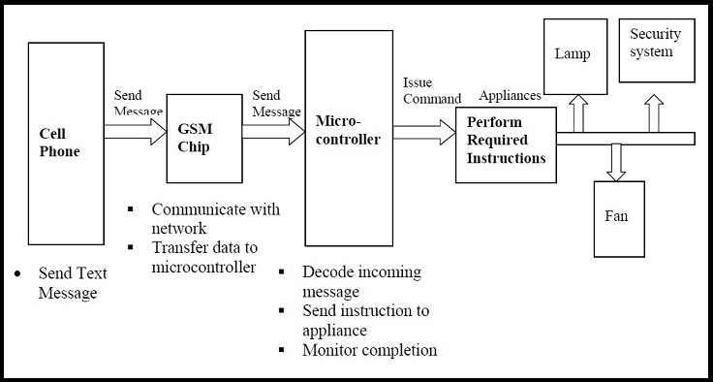

1. **Cloud Based home automation system:**

Home Automation using cloud based system focuses on design and implementation of home gateway to collect data about data from home appliances and then send to the cloud-based data server to get store on Hadoop Distributed File System, it is process using MapReduce and use to implement a monitoring tasks to Remote user Presently home Automation System is persistently developing its resilience by assimilating the current characteristics which gratify the rising interest of the people. This paper presents the design and development of home automation system that use the cloud computing as service. The current system consists of three important units: the first part is cloud server, handle and controls the data and information of client and users and the status of devices the hardware interface module is the second part which implement the relevant connection to the actuators and sensing devices which give the physical service. Last part is Home Server, which construct the hardware device and gives the user interface. This paper focus to build the web services using cloud which is need for security and storage and availability of the data. The current system is cost efficient, reliable and comfortable which also gives a secured home automation system for entire family. The system is made up of various client modules for various platforms.

1. Cloud server

Cloud Server is a central server aims on implementing services to the other sub modules. Central server serves as the data respiratory system and brain it implements three connections to the three sub modules viz home system, web configuration tool and mobile. The server evaluates the data it takes from the house, send current status to the mobile device and vice versa. A database is managing by the server and it is status gets updated as per the changes done at home end. 2. Embedded Program for Hardware Circuit Microcontroller, and. 3. Internet Client for any desktop or mobile phones.

1. **Raspberry pie home automation with wireless sensors using smart phone**

Home Automation System has been developed with Raspberry Pi by reading the algorithm and subject of E-mail. Raspberry Pi guarantees to be an efficient platform for implementation powerful, and economic smart home automation. Home automation using Raspberry pi is better than any other home automation methods in several ways. For example, DTMF (dual tone multi-frequency) using home automation, the call tariff is a big demerit, which is not the problem in their proposed method. In Home Automation using web server, the design of web server and the memory space required is dismiss by this method, because it just uses the already established web server service given by G-mail. LEDs were used to identify the switching action. This System is efficient and flexible interactive.

**Sending Commands to the Raspberry Pi**

The script running on server side of our laptop or on a web server receives the input commands from the user and appropriately sends it to the client (Raspberry Pi). In this, we will be using those input commands to turn a light ON/OFF. When we give the command to turn ON a light by the server-side script, the data and information gets relayed to the Raspberry Pi and its GPIO pin will turns ON a relay. The system can send current updates to the server to detect whether the light is ON/OFF.



1. **Home automation using RF module:**

The important goal of Home Automation System is to build a home automation system using a RF controlled remote. Now technology is accelerating so homes are also getting smarter. Modern homes are deliberately relocating from current l switches to centralized control system, containing RF controlled switches. Today traditional wall switches situated in various parts of the home makes it laborious t for the end user to go near them to control and operate. Even further internistmore problematic for the old persons or physically handicapped people to do so. Home Automation using remote implements an easier solution with RF technology. In order to accomplish this, a RF remote is combined to the microcontroller on transmitter side that sends ON/OFF signals to the receiver where devices are connected. By operating the stated remote switch on the transmitter, the loads can be.

1. **Wi-Fi based home automation system using cell phones:**

Wi-Fi based home automation system mainly consist three modules, the server, the hardware interface module, and the software package. The figure shows the system model layout. Wi-Fi technology is used by server, and hardware Interface module to communicate with each other. The same technology uses to login to the server web-based application. The server is connected to the internet, so remote users can access server web-based application through the internet using compatible web browser. Software of the latest home automation system is split to server application software, and Microcontroller (Arduino) firmware. The Arduino software, built using C language, using IDE comes with the microcontroller itself. Arduino software is culpable for gathering events from connected sensors, then applies action to actuators and preprogramed in the server.

**Chapter 3: Proposed Methodology of Solving Identified Problem**

In order to achieve this, a relay module is interfaced to the Node MCU board at the receiver end while on the transmitter end, a GUI application on the cell phone sends ON/OFF commands to the receiver where loads are connected. By touching the specified location on the widgets, the AC loads can be switched ON/OFF remotely through this technology.

**2. BLOCK DIAGRAM**



**Fig. 1 Block Diagram of Home Control**

To achieve the home control using smart phone, initially the mobile unit should be connected to any network and the Wi-Fi module ESP8266 which is on Node MCU should be connected to local network. By touching the specified location of widgets in the blynk app, this blynk app sends ON/OFF commands to ESP8266 on Node MCU via Blynk server. Then the relays connected to Node MCU perform switching operation corresponding to the input. So that the loads connected to relays will be switched ON/OFF. Similarly, we can also control our home appliances using manual switches. This can be obtained by connecting the relays outputs to manual switches and manual switches to the AC loads. Whenever the relay corresponding to manual ON or OFF is switched ON then the AC loads corresponding to that switches will perform switching operation.

**1) Node MCU**



**Fig. 2 Pin Diagram of Node MCU**

The Node MCU (Node Micro Controller Unit) is open source software and hardware development environment that is built around a very inexpensive System-on-a-Chip (SoC) called the ESP8266. The ESP8266 designed and manufactured by Espress if Systems, contains all crucial elements of the modern computer: CPU, RAM, networking (Wi-Fi), and even a modern operating system and SDK.

**NodeMCU** is an open source [IoT](https://en.wikipedia.org/wiki/Internet_of_Things) platform. It includes [firmware](https://en.wikipedia.org/wiki/Firmware) which runs on the [ESP8266](https://en.wikipedia.org/wiki/ESP8266) [Wi-Fi](https://en.wikipedia.org/wiki/Wi-Fi) [SoC](https://en.wikipedia.org/wiki/System_on_a_chip) from Espressif Systems, and hardware which is based on the ESP-12 module. The term "NodeMCU" by default refers to the firmware rather than the development kits. The firmware uses the Lua scripting language. It is based on the Eula project, and built on the Espressif Non-OS SDK for ESP8266. It uses many open source projects, such as lua-cjson and [SPIFFS](https://en.wikipedia.org/w/index.php?title=SPIFFS&action=edit&redlink=1).

As [Arduino.cc](https://en.wikipedia.org/wiki/Arduino) began developing new MCU boards based on non-[AVR](https://en.wikipedia.org/wiki/AVR_microcontrollers) processors like the ARM/SAM MCU and used in the Arduino Due, they needed to modify the [Arduino IDE](https://en.wikipedia.org/wiki/Arduino_IDE) so that it would be relatively easy to change the IDE to support alternate toolchains to allow Arduino C/C++ to be compiled for these new processors. They did this with the introduction of the Board Manager and the SAM Core. A "core" is the collection of software components required by the Board Manager and the Arduino IDE to compile an Arduino C/C++ source file for the target MCU's machine language. Some ESP8266 enthusiasts developed an Arduino core for the ESP8266 Wi-Fi SoC; popularly called the "ESP8266 Core for the Arduino IDE" This has become a leading software development platform for the various ESP8266-based modules and development boards, including NodeMCU.

**2) Relay**



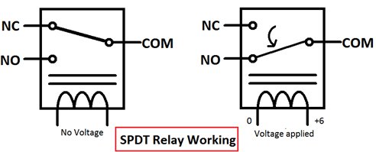

A **relay** is an [electrically](https://en.wikipedia.org/wiki/Electric) operated [switch](https://en.wikipedia.org/wiki/Switch). It consists of a set of input terminals for a single or multiple control signals, and a set of operating contact terminals. The switch may have any number of contacts in multiple [contact forms](https://en.wikipedia.org/wiki/Electrical_contact#Contact_form), such as make contacts, break contacts, or combinations thereof.

Relays are used where it is necessary to control a circuit by an independent low-power signal, or where several circuits must be controlled by one signal. Relays were first used in long-distance [telegraph](https://en.wikipedia.org/wiki/Electrical_telegraph) circuits as signal repeaters: they refresh the signal coming in from one circuit by transmitting it on another circuit. Relays were used extensively in telephone exchanges and early computers to perform logical operations.

The traditional form of a relay uses an [electromagnet](https://en.wikipedia.org/wiki/Electromagnet) to close or open the contacts, but other operating principles have been invented, such as in [solid-state relays](https://en.wikipedia.org/wiki/Solid-state_relay) which use [semiconductor](https://en.wikipedia.org/wiki/Semiconductor) properties for control without relying on [moving parts](https://en.wikipedia.org/wiki/Moving_parts). Relays with calibrated operating characteristics and sometimes multiple operating coils are used to protect electrical circuits from overload or faults; in modern electric power systems these functions are performed by digital instruments still called [*protective relays*](https://en.wikipedia.org/wiki/Protective_relay).

Latching relays require only a single pulse of control power to operate the switch persistently. Another pulse applied to a second set of control terminals, or a pulse with opposite polarity, resets the switch, while repeated pulses of the same kind have no effects. Magnetic latching relays are useful in applications when interrupted power should not affect the circuits that the relay is controlling.

**3) RGB LED**

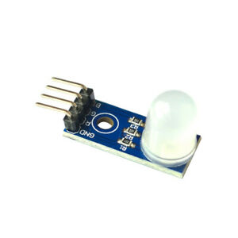

RGB [LED](https://www.lighting.philips.com/main/education/lighting-academy/lighting-academy-browser/video/LEDs) means red, blue and green [LEDs](https://www.lighting.philips.com/main/education/lighting-academy/lighting-academy-browser/video/LEDs). RGB [LED](https://www.lighting.philips.com/main/education/lighting-academy/lighting-academy-browser/video/LEDs) products combine these three colors to produce over 16 million hues of light. Note that not all colors are possible. Some colors are “outside” the triangle formed by the RGB [LEDs](https://www.lighting.philips.com/main/education/lighting-academy/lighting-academy-browser/video/LEDs). Also, pigment colors such as brown or pink are difficult, or impossible, to achieve.

**4) LDR Sensor Module**

The LDR Sensor Module is used to detect the presence of light / measuring the intensity of light. The output of the module goes high in the presence of light and it becomes low in the absence of light. The sensitivity of the signal detection can be adjusted using potentiometer.

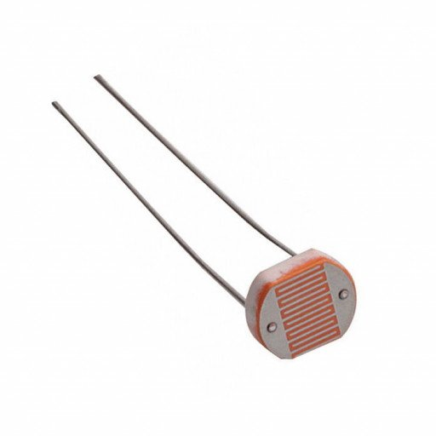

**Features: -**

* Can detect ambient brightness and light intensity
* Adjustable sensitivity (via blue digital potentiometer adjustment)
* Operating voltage 3.3V-5V

***5) DHT 11***

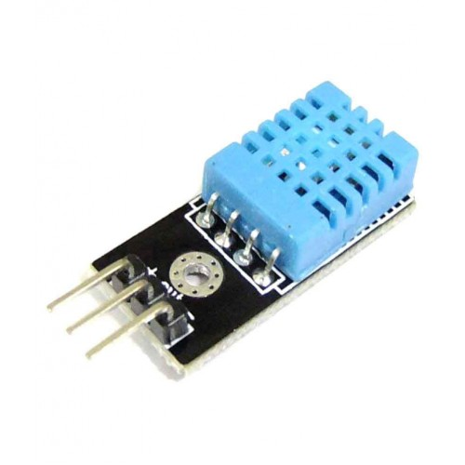

DHT11 is a Humidity and Temperature Sensor, which generates calibrated digital output. DHT11 can be interface with any microcontroller like Arduino, Raspberry Pi, etc. and get instantaneous results. DHT11 is a low-cost humidity and temperature sensor which provides high reliability and long-term stability.

It uses a capacitive humidity sensor and a thermistor to measure the surrounding air, and outputs a digital signal on the data pin (no analog input pins needed). It’s very simple to use, and libraries and sample codes are available for Arduino and Raspberry Pi.

This module makes is easy to connect the DHT11 sensor to an Arduino or microcontroller as includes the pull up resistor required to use the sensor. Only three connections are required to be made to use the sensor - Vic, Gnd and Output.

It has high reliability and excellent long-term stability, thanks to the exclusive digital signal acquisition technique and temperature & humidity sensing technology.

**Specifications: -**

* Power Supply： 3.3~5.5V DC
* Output： 4 pin single row
* Measurement Range： Humidity 20-90%RH， Temperature 0~50℃
* Accuracy： Humidity +-5%RH， Temperature +-2℃
* Resolution： Humidity 1%RH， Temperature 1℃
* Interchangeability： Fully Interchangeable
* Long-Term Stability：<±1%RH/year

**Pin Description: -**

* Pin 1:     Power +Ve (3.3VDC to 5.5VDC Max wrt. GND)
* Pin 2:     Serial Data Output
* Pin 3:     Power Ground or Power –Ve

**5) Blynk App& Arduino IDE Software**

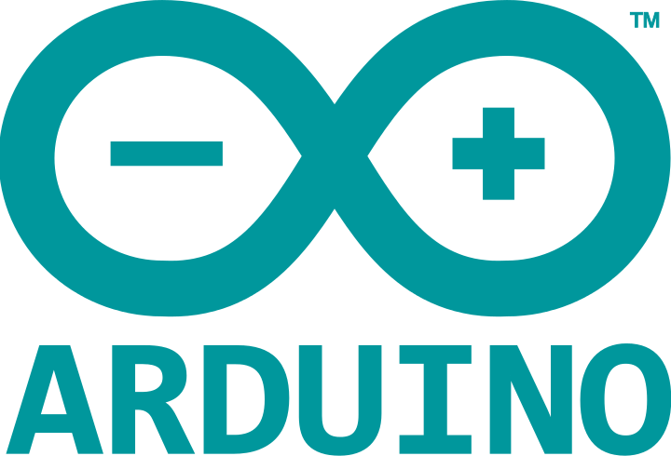

Blynk is a Platform with iOS and Android apps to control Arduino, Raspberry Pi and the likes over the Internet. It’s a digital dashboard where we can build a graphic interface for our project by simply dragging and dropping widgets. Blynk is not tied to some specific board or shield. Instead, it's supporting hardware of our choice. Whether our Arduino or Raspberry Pi is linked to the Internet over Wi-Fi, Ethernet or this new ESP8266 chip, Blynk will get you online and ready for the Internet of Your Things.

Arduino is an open-source platform used for building electronics projects consists of both a physical programmable circuit board (often referred to as a microcontroller) and a piece of software, or IDE (Integrated Development Environment) that runs on your computer, used to write and upload computer code to the physical board.

***Action Plan***

|  |  |  |
| --- | --- | --- |
| ***Task*** | ***Week*** | ***Assigned To*** |
| Looking for the Topics | Week 1 | Whole Group |
| Deciding the Topic | Week 2 | Whole Group |
| Getting more Information about the Selected topic | Week 3 | Whole Group |
| Materials that would be needed | Week 4 | Whole Group |
| Material Bought | Week 5 | Dewam Katole & Ritvik Nimje |
| Materials Checked and Tested | Week 6 | Dewam Katole |
| Material Assembled | Week 7 | Aniruddha Kate |
| Coding | Week 8 | Amaan Ranapurwala |
| Blynk App Configuration | Week 9 | Amaan Ranapurwala & Aniruddha Kate |
| Blynk App Modification | Week 10 | Dewam Katole |
| Configuring the Blynk app with the NodeMCU | Week 11 | Amaan Ranapurwala |
| Complete Assembling of the Project | Week 12 | Aniruddha Kate & Ritvik Nimje |
| Project Implementation | Week 10 | Dewam Katole |
| Project Testing | Week 11 | Whole Group |

**Reference& Bibliography**

<https://www.google.com>

<https://www.youtube.com>

<https://www.coursera.org>

<https://en.wikipedia.org/wiki/Electronic_component>